Basic Databases – Report01
Wroclaw University of Technology, Date: October 12, 2018
Student: | Email: 242363@studnet.pwr.edu.pl | Grade
Identifier | 242363
First name | Patryk
Last name | Szwed
This task consists of 1 problem. If you cannot solve a complete problem, try to give a partial answer. Remember to write your name, and identifier.
Problem 1
Please create a database which allows you store information about books you have read, you are reading, or you are going to read.
- Analyze different ways of book specification and based on the gain information prepare conceptual data model using UML language (class diagram)
Examples of data about books:
  - Incomplete specification


A Short Introduction to Databases
Author(s): Viji Kumar
Category: Computer & Internet
ISBN
Rating: Rated: 1 times
Format: PDF, ePub, Kindle, TXT
Publisher: ?
Published: May 2016
Pages: 56
?:

  - Bibliographic specification:
- Vermeer, Leslie (2016-08-31). The Complete Canadian Book Editor. Brush Education. ISBN 9781550596779.
- Gary B. Shelly; Joy L. Starks (6 January 2011). Microsoft Publisher 2010: Comprehensive. Cengage Learning. p. 559. ISBN 978-1-133-17147-8.

  - Additional sources of book descriptions: 20 Books You Really Should Have Read By Now
https://www.rd.com/culture/14-books-you-really-should-have-read-by-now/

Create a conceptual data model taking into account the rules of the domain of mention above description
- Identify and define classes of objects including basic properties (attributes, candidate keys, constraints) e.g. Book(ISBN, Title, …)
- Define business rules
- Define class diagram

Place the results of each subtask in the in the below parts of the report

Solution
- Class definitions

Class Author has three fields:
  - Two Strings: firstName, lastName
  - One int: PESEL
PESEL is the candidate key in this class.

Class Book has six fields:
  - Three Strings: title, category, formats
  - Two int: ISBN, pages
  - One double: rating
ISBN is the candidate key in this class.

Class Publisher has two fields:
  - One String: name
  - One int: NIP
NIP is the candidate key in this class. In addition, when a publisher publishes a book, it also attaches a publishDate of type Date.

Class Reader has four fields:
  - Two Strings: firstName, lastName
  - Two int: PESEL, booksRead
PESEL is the candidate key in this class. In addition, when a reader reads a book, they also attach a rate of type double.

- Business rules

Each author can write from one to many books. Each book can be written by one or more authors. Each reader can read from zero to many books. Each book can be read by zero or more readers. Each book can have only one publisher. Each publisher can publish from one to many books.

- Class diagram

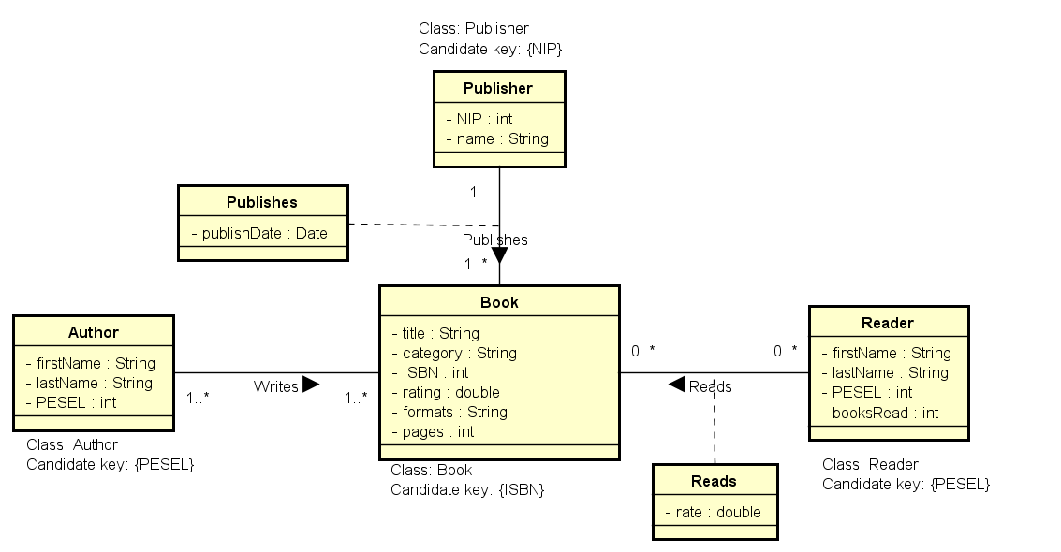
Conclusions
?

Please do not forget about the conclusions being a summary of considered problems and proposed solutions!
Remarks:
- Students' reports (as one package) should be sent by the leader of the group via e-mail before the next lab
- The rule of naming student’s file report is defined below

Name of the file: Rep01-StudId-Last name.pdf | Example: Rep01-1951355-Turan.pdf

